Software Requirements Specification
For SpeedSplit
Version 6
Prepared by Alan Obszański
Faculty of Electrical, Electronic, Computer and Control Engineering
at Lodz University of Technology
24.04.2026

Table of Contents
Contents
1. Introduction 4
1.1. Purpose 4
1.2. Document Conventions 4
1.3. Intended Audience and Reading Suggestions 4
1.4. Product Scope 4
1.5. References 4
2. Overall Description 4
2.1. Product Perspective 4
2.2. Product Features 4
2.3. User Classes and Characteristics 7
2.4. Operating Environment 7
2.5. Design and Implementation Constraints 7
2.6. Assumptions and Dependencies 8
3. System Features 8
3.1. Stopwatch 8
3.2. Categories 8
4. External Interface Requirements 8
4.1. User Interfaces Overview 8
4.2. Hardware Interfaces 8
4.3. Software Interfaces 8
5. System Features/Modules 9
5.1. Stopwatch 9
5.1.1 Description and Priority 9
5.1.2 Stimulus/Response Sequences 9
5.1.3 Functional Requirements 9
6. Nonfunctional Requirements 9
6.1. Performance 9
6.2. Security 9

Revision History

Name | Date | Reason for Changes | Version
Alan Obszański | 24.04.2026 | Initial version: filling out all the template sections, without any diagrams | V1
Alan Obszański | 25.04.2026 | Add Use Case Diagram | V2
Alan Obszański | 26.05.2026 | Add Class Diagram | V3
Alan Obszański | 11.06.2026 | Cut down the features according to the instructor’s suggestions | V4
Alan Obszański | 11.06.2026 | Add Sequence, State and Activity Diagrams | V5
Alan Obszański | 11.06.2026 | Remove template text, add table of contents, improve formatting | V6

1. Introduction

1.1. Purpose
The purpose of SpeedSplit is to enable simple, intuitive and flexible timing of various user-defined tasks, as well as to provide a convenient way to collect and analyze gathered data.

1.2. Document Conventions
Necessary program functionality shall be stated using the verb “shall”, as in “The program shall measure time with less than 1ms of inaccuracy”.
There are a few speedrun-related terms used throughout this document, which will be explained here for clarity:
- Run – one specific measured time period. Usually tracks one activity.
- Split – a sub-period of time within a run, marking a sub-goal or checkpoint.

1.3. Intended Audience and Reading Suggestions
This document contains all information about the functionality of SpeedSplit. It is created for the developers (Alan Obszański, Wiktor Mandra), as well as the project manager (dr. inż. Abdulla Juwaied)

1.4. Product Scope
The program shall allow the user to run a stopwatch with the possibility of pausing it or marking checkpoints, also known as “splits”. The user shall be able to export a run as a .csv file.

1.5. References
This document is based on the IEEE 830 template and was created as part of the 2025/2026 4th semester Software Engineering course.

2. Overall Description

2.1. Product Perspective
SpeedSplit is a standalone app, inspired by programs such as LiveSplit, but designed primarily for mobile use and not targeted specifically for game speedruns, rather for timing real-life tasks and processes.

2.2. Product Features
- Basic but very precise stopwatch.
- Ability to add “splits” during a run
- Ability to export collected data as a CSV file
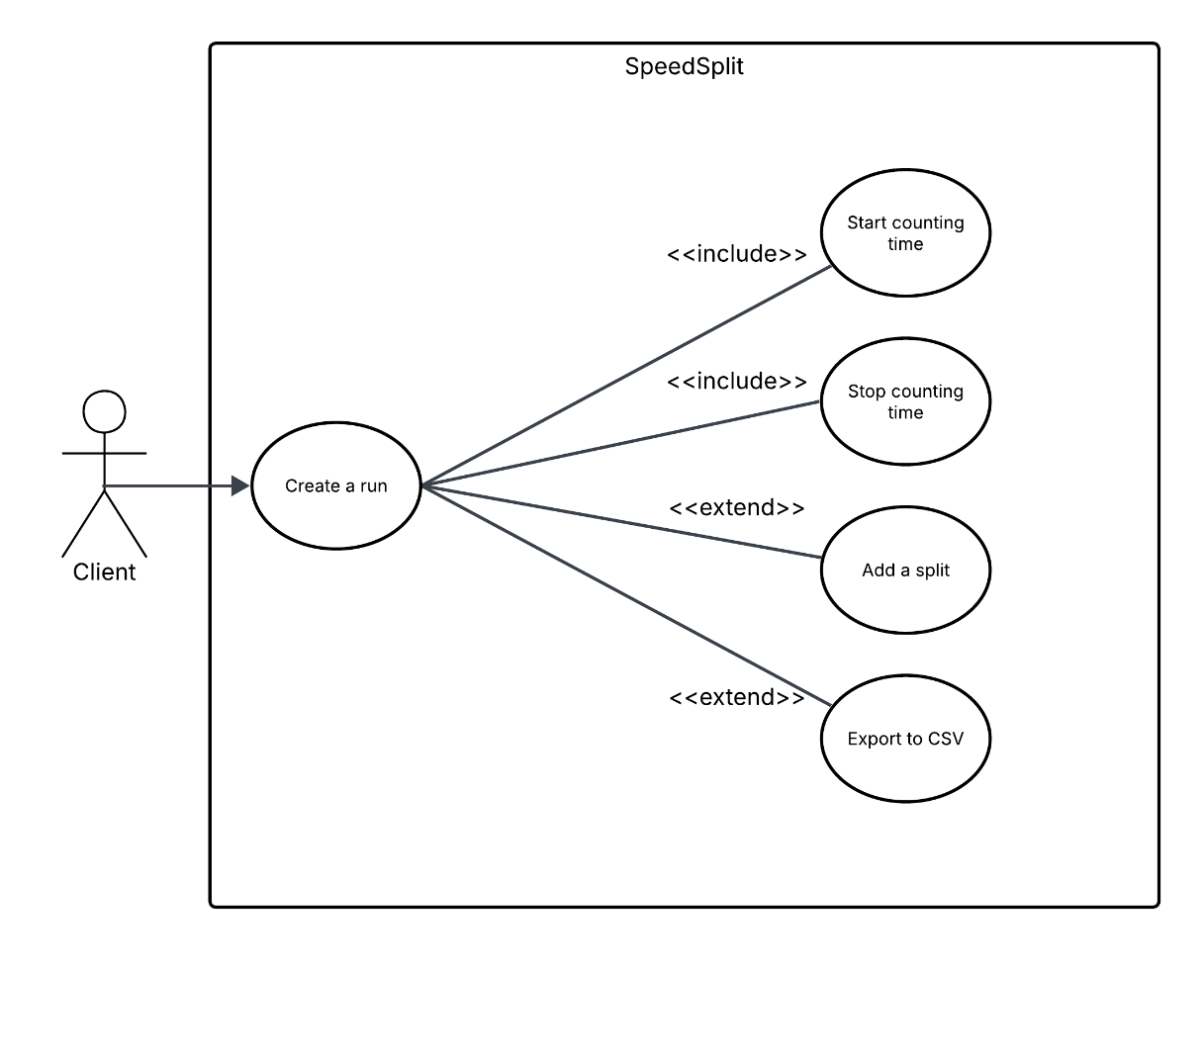
Figure 1. SpeedSplit Use Case Diagram, highlighting the main features of the app: making runs, adding splits and exporting to CSV.
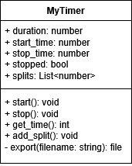
Figure 2. Speedsplit Class Diagram
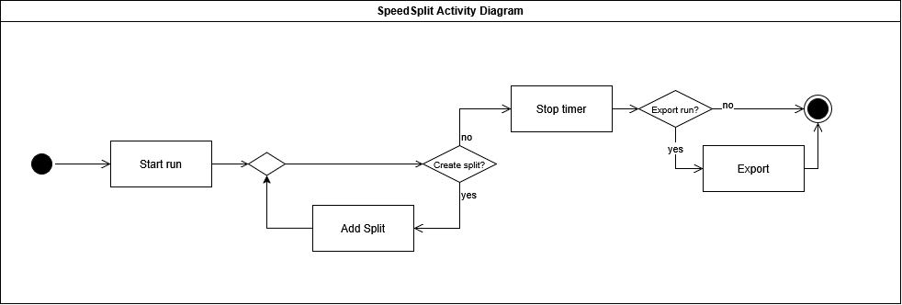
Figure 3. SpeedSplit Activity Diagram, showing all the paths a user of the program may take.
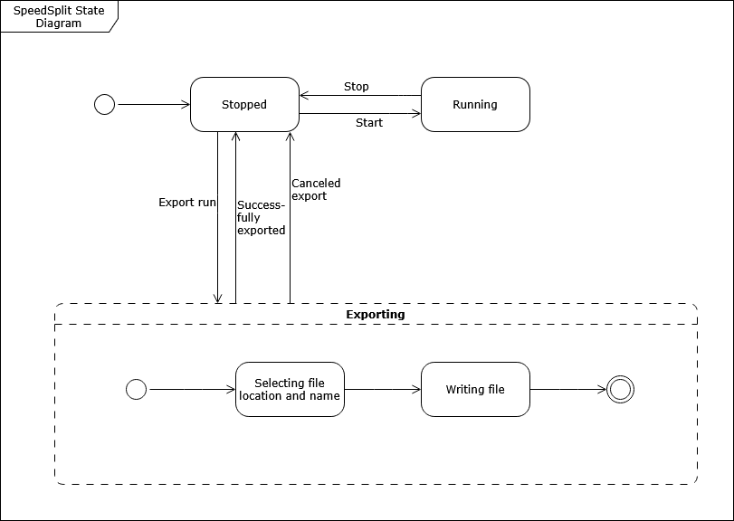
Figure 4. SpeedSplit State Diagram, showing all the different states the program may be in.
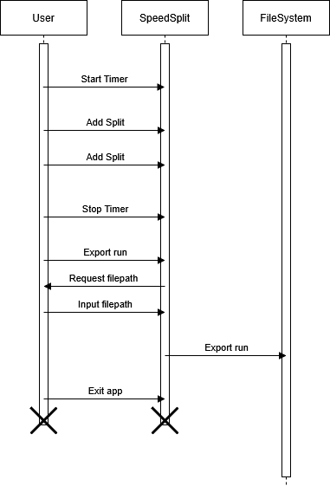
Figure 5. SpeedSplit Sequence Diagram, showing information throughput over time between the user, app and the user's file system.

2.3. User Classes and Characteristics
People with an interest in speedrunning, looking to expand that hobby into daily tasks
People looking to time and statistically analyse daily activities out of curiosity.

2.4. Operating Environment
Any mobile device that operates a somewhat modern Android version.

2.5. Design and Implementation Constraints
Exact timing might prove to be a challenge, care will need to be taken to ensure that timing isn’t tied to framerate and is updated as quickly as possible. Android file modification permissions might also cause issues.

2.6. Assumptions and Dependencies
The app might be created using the Godot Engine, as it’s a capable and easy-to-use framework for creating not only videogames, but also various utility apps.

3. System Features

3.1. Stopwatch
The main feature of the app is the stopwatch. It can be started, paused and stopped by direct user input, and its measured data are displayed on the screen.

3.2. Categories
Before or after a run is completed, the used may assign it to a category (identified by a text string). By default, a run is displayed as “Uncategorized”. Runs from the same category may be viewed together in a list and exported as an .xlsx Excel file for further analysis.

4. External Interface Requirements

4.1. User Interfaces Overview
The app shall show a large timer in the center with three buttons below it to begin counting time. The buttons, from left to right, are as follows: “Start”, “Split”, “Stop”. Upon pressing the “Start” button, the timer shall immediately start counting time from zero. Pressing the “Split” button shall immediately add a split to the run at the current timestamp, additionally displaying it in a list view below the buttons. Pressing the “Stop” button shall stop the stopwatch.
Below the buttons, there shall be a scrollable list view that is empty at the start, and whenever the user presses the “Split” button, its timestamp shall be inserted into the list.
In the bottom-right corner, there shall be an “Export to CSV” button, which, upon being clicked, shall prompt the user for the location and name of the newly-created file, and afterwards, save the timer’s start, split and stop timestamps there.

4.2. Hardware Interfaces
Hardware interfacing shall be handled by the Godot Engine’s built-in implementations for Android.

4.3. Software Interfaces
None

5. System Features/Modules

5.1. Stopwatch

5.1.1 Description and Priority
The stopwatch can be started, paused and stopped by direct user input, and its duration (alongside splits) can be saved after completion. It’s the main feature of the app, so its functionality is of highest priority.

5.1.2 Stimulus/Response Sequences
Stimulus: The user presses the Start button.
Response: The timer starts counting time upwards, from zero.
Stimulus: The user presses the Split button.
Response: A new text label is added to the list view below the buttons, showing the timestamp at the moment of pressing the button.
Stimulus: The user presses the Stop button.
Response: The timer freezes at its current timestamp.
Stimulus: The user presses the Export to CSV button.
Response: The user is prompted with a system file dialog to select a folder and filename. Afterwards, the app creates a file in the CSV format in that location on the device.

5.1.3 Functional Requirements
REQ-1.1: Upon pressing the “Start” button, the timer shall start measuring elapsed time.
REQ-1.2: Upon pressing the “Split” button, a new split shall be added to the current run at the timestamp of the button being pressed.
REQ-1.3: Upon pressing the “Stop” button, the timer shall stop measuring time.
REQ-1.4: Upon pressing the “Export” button, the current run shall be saved as a CSV file on the user’s device.
REQ-1.5: The timer shall be less than 1ms imprecise.

6. Nonfunctional Requirements

6.1. Performance
The app is intended to be very lightweight, so performance should not be a concern in any case except very heavy system load.

6.2. Security
The app shall not collect or store any personal information, so all its data can be safely stored in an unencrypted format for quicker access and direct user modification.

